MySQL Assignment (Assignment-1)
Name: Ayan Parashar (28th Jan, 2026) Date: February 9, 2026

1. Database Creation
Objective: Create two tables (Authors and Books) and insert sample data.
SQL Commands:
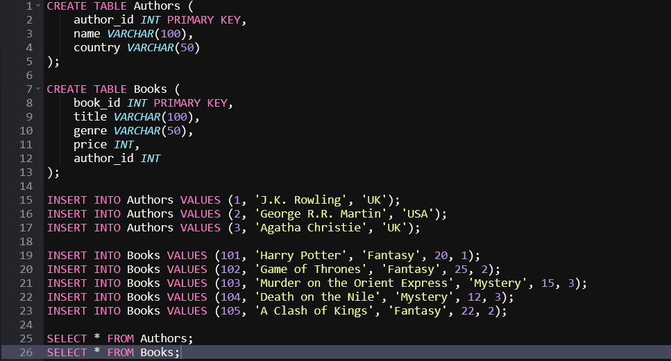Output: 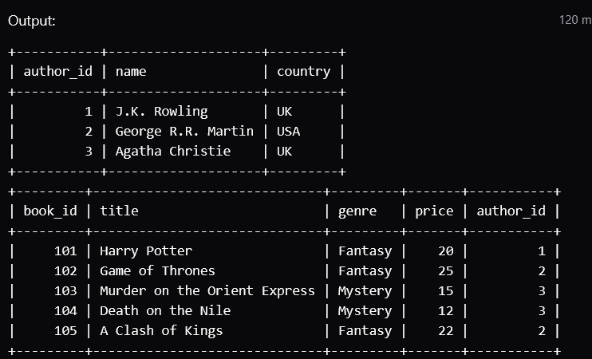

2. Conditional Operations
A. WHERE with AND Fetch books that are 'Fantasy' genre AND have a price greater than 20.
Command: SELECT * FROM Books WHERE genre = 'Fantasy' AND price > 20;
Output: 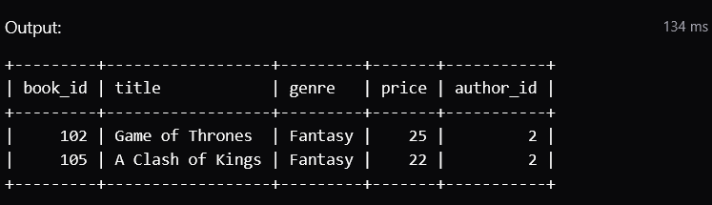
B. WHERE with OR Fetch books that are 'Mystery' genre OR have a price of exactly 25.
Command: SELECT * FROM Books WHERE genre = 'Mystery' OR price = 25;
Output: 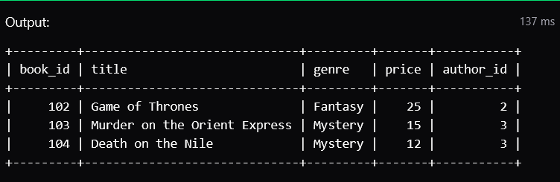
C. WHERE with NOT Fetch authors who are NOT from the UK.
Command: SELECT * FROM Authors WHERE NOT country = 'UK';
Output: 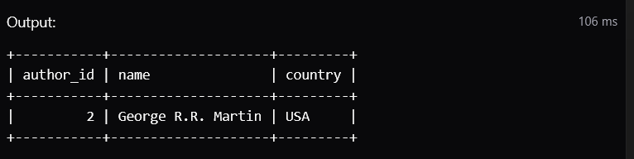

3. Sorting and Pattern Matching
A. ORDER BY List all books sorted by price in descending order.
Command: SELECT * FROM Books ORDER BY price DESC;
Output: 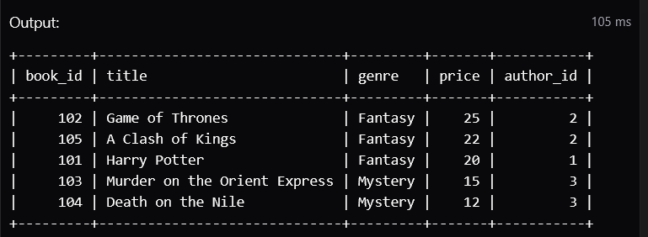
B. LIKE Find books where the title starts with 'Harry'.
Command: SELECT * FROM Books WHERE title LIKE 'Harry%';
Output: 